Module :- 1(SDCL)

Name :- Dharmi Nagar

Q:-1 what is software ? what is software engineering?

Software is a set of instruction ,data or programs used to operate computers and execute specific tasks.

Software engineering:- Software engineering is the discipline of designing, developing, testing, and maintaining software applications using structured methodologies and principles. It involves various phases such as requirements gathering, design, coding, testing, and deployment, with the goal of producing high-quality, efficient, and reliable software that meets user needs.

Q:-2 Explain Types Of Software

1.Application software

This software is designed for end-users to perform specific tasks. It runs on top of system software and can be general-purpose or specialized.

2.System software

This type of software manages and controls the hardware components of a computer, enabling other software to function. It acts as a platform for running application software.

3.Driver software

Driver software acts as a mediator between hardware devices and the operating system. It translates the OS’s instructions into commands that the hardware understands.

4.Programming software

These tools help developers write, test, and maintain code for various applications or system software.

5.Middleware

Middleware connects different software applications or components, allowing them.

Q:-3 What is SDCL? Explain each phase of SDCL

Software development life cycle refers to a method for creating high-quality software.

1.planning:- This is the initial phase where the project goals, scope, and requirements are defined. It involves resource allocation, risk management, and setting timelines. The feasibility of the project is also evaluated during this stage.

2.analisys:- During this phase, detailed requirements are gathered from stakeholders. Business analysts work with end-users and clients to understand their needs, which are then documented in a Software Requirement Specification (SRS) document. The feasibility and technical aspects are also analyzed.

3.designing:- In the design phase, architects and developers create the high-level and low-level design of the software. This includes system architecture, database design, user interfaces, and more. It’s where decisions are made about the technology stack and overall structure of the application.

4.implementation:- This is the phase where developers write code based on the design documents. The software components are created, integrated, and prepared for testing. This phase also includes unit testing, where individual components are tested for functionality.

5.testing:- The testing phase involves validating the software to ensure it meets the requirements defined in the earlier phases. Different types of testing (unit testing, integration testing, system testing, and user acceptance testing) are performed to identify and fix bugs.

6.maintanence:- After deployment, the software enters the maintenance phase. In this stage, the software is monitored for issues, bugs are fixed, updates and enhancements are made, and ongoing support is provided. Maintenance is crucial to ensure the software continues to function well over time.

Q:-4What is DFD? Create a DFD diagram on Flipcart

A DFD (Data Flow Diagram) is a graphical representation used to visualize how data flows within a system, including where the data comes from, how it is processed, and where it goes. It is a key tool in system design, especially during the early stages of software development, to illustrate the flow of information and processes involved.

DFD Diagram on Flipcart

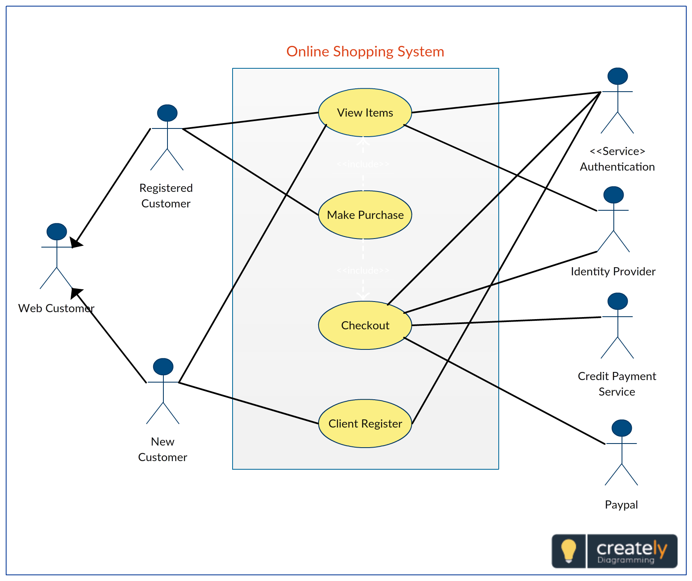

Q:-5what is flow chart? Create a flow chart to make addition of two numbers.

A flowchart is a diagram that represents a process, system, or algorithm. It uses standardized symbols to depict steps or actions in a sequence, along with arrows to show the flow of control from one step to the next. Flowcharts help visualize how a process works, making it easier to understand and troubleshoot

Flow chart

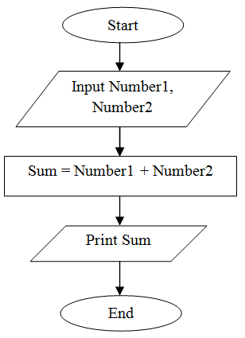

Q:-6 what is use-case diagram? Create use-case on bill payment on paytm

A use-case diagram is a type of diagram in Unified Modeling Language (UML) that visually represents the interactions between users (actors) and a system to capture its functional requirements. It shows what the system does (use cases), who interacts with it (actors), and how those interactions are organized.

